A198-Afr-Egy-Ushabti-Saite Period, 26th Dynasty, 570-525 BCE

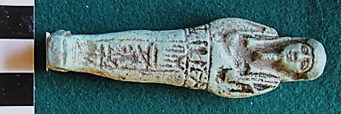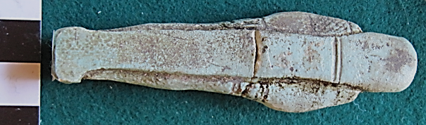

Figs. 1-2. Ushabti-Saite Period, 26th Dynasty, 570-525 BCE

**Case No.: 2**

**Formal Label:** Ushabti-Saite Period, 26th Dynasty, 570-525 BCE

**Display Description:**

This mummiform Ushabti, Saite Period, 26th Dynasty, 570-525 BCE, has a plain, tripartite wig, arms crossed right over left on the chest and the right hand is holding a pick and a seed basket that is flung over the left shoulder, and the left hand is holding a hoe. There is a shallow dorsal pillar which merges with the wig, and the entire Ushabti is placed on a trapezoidal base. A detailed “T” shaped inscription names the owner even though this is a diminutive Ushabti

Ushabtis were sculpted during this period with a back pillar, which may have an inscription. Hieroglyphs may also be impressed into the Ushabti using a mold or were applied manually, in which case both the outline and the inside of the hieroglyph can be embellished. Two hoes that are visible on the workers’ upper arms from the 18th dynasty are replaced by one pick and one hoe. The back pillar and the feet of the Ushabtis are placed on a trapezoid block. Until this dynasty the false Osirian god’s beard was only worn by select members of the royal family, including the pharaoh. Beginning with the Saite period private persons were also allowed to wear a false beard.

**Accession Number: A198**

**LC Classification:** DT62

**Date or Time Horizon:** Saite Period, 26th Dynasty, 570–525 BCE, Reign of Amasis

**Geographical Area: Sais, Egypt**

**Map, GPS Coordinates:** 30.96650 30.76751, 30º57'59.41" N 30º46'3.02" E

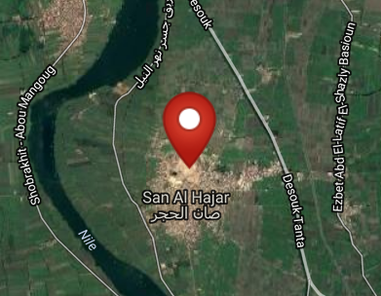 

Fig. Left. Sais on the Nile after http://latitude.to/lat/30.96606/lng/30.76785. Fig. Sais reconstructed according to Jean-Claude Golvin, http://jeanclaudegolvin.com/sais-2/.

**Cultural Affiliation:** Saite Period, 26th Dynasty, 570-525 BCE

**Medium:** faience, blue-green glaze

**Dimensions: H 9 cm; 3 9/16 in  
Weight: 21 gm; 5/8 oz**

**Provenance: European collection.**

**Condition:** original

**Discussion:** This Ushabti was sculpted during the reign of Psamtek I with his capital Sais in the delta. He reunited Egypt and strengthened trade and cultural connections with the Greeks during a period of prosperity, called the “Saite renaissance,” which led to the creation of beautiful Ushabtis. Attention was devoted to Ushabti design, quality, workmanship and details. Until the 30th dynasty this Saite faience style changed very little. Although the typical form of the overseer in the dress of daily life no longer occurred, it is likely that it did not disappear, since in many tombs large numbers of blank or partially inscribed Ushabtis are found together with larger specimens containing the full text of the usual Ushabti formula and these manifested the transformed role of overseer.

This green glaze faience Ushabti is similar to one in the San Francisco Museum of Art. acc. no. 1925.81

**References:**

Aubert, J.-F. et L. Aubert. 1974. *Statuettes Egyptiennes: Chaouabtis, Ouchebtis.* Paris, 1974.

Janes, Glenn. 2002. *Shabtis. A Private View, Ancient Egyptian Funerary Statuettes in European Private Collections.* Paris: Cybèle.

Newberry, Percy E. 1930-1957. *Funerary Statuettes and Model Sarcophagi.*  Le Caire: Impr. de l'Institut français d'archéologie orientale.

Schneider, Hans D. 1977. *Shabtis - An Introduction to the History of Ancient Egyptian Funerary Statuettes. With a Catalogue of the Collection of Shabtis in the National Museum of Leiden*. (3 volumes, Leiden: Rijksmuseum van Oudheden Te Leiden.

Schlögl, Hermann and Andreas Brodbeck. 1990. *Ägyptische Totenfiguren aus öffentlichen und privaten Sammlungen der Schweiz.* Orbis Biblicus et Orientalis, Series Archeologica, 7. Göttingen, Vandenhoeck & Ruprecht; Freiburg Schweiz, Universitätsverlag.